Hands-On Practice 1: Configure a logo and a photograph



Hands-On Practice 2: Background image

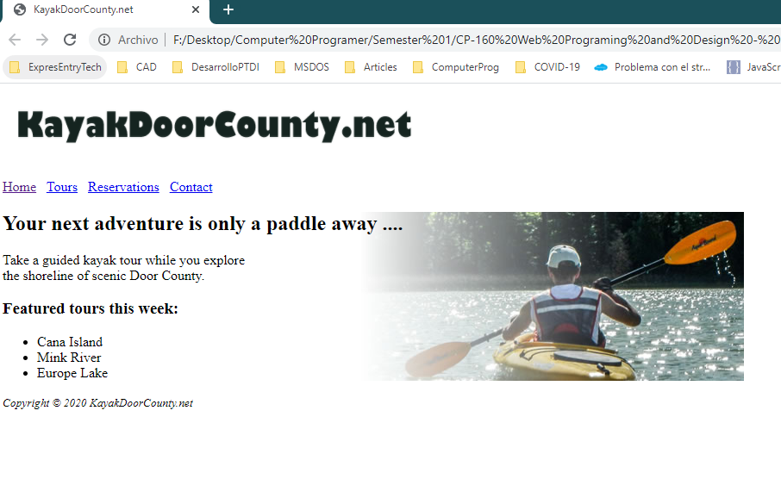

Hands-On Practice 3: Configure the font-family property

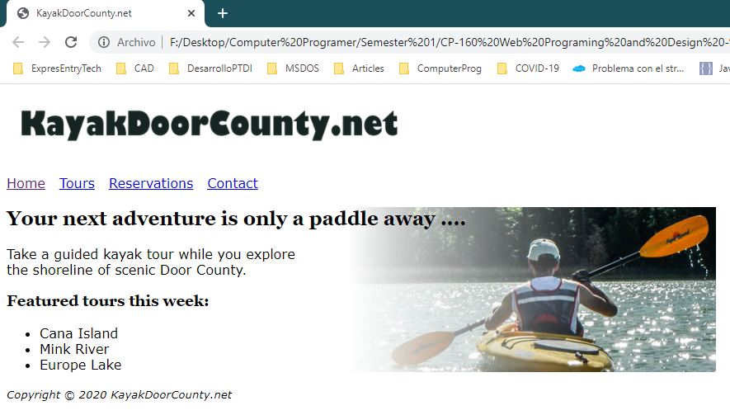

Hands-On Practice 4: Configure images and text



Hands-On Practice 5: Image with a caption

